Name :- Bhuvisha Gohil
Cohort :- Demis Hassabis
Roll No :- 150096725190
Subject :- Backend Development –
Node.js, MongoDB & Firebase.
Course :- B.Tech CSE
Professor :- Ricky Kumar

ASSIGNMENT 2

Assignment 1: Basic HTTP Server — 10 Marks
Question
Create a basic HTTP server using Node.js that displays a welcome message in the browser.
Develop a Node.js application that:

- Create an HTTP server using the built-in http module.
- Run the server on Port 3000.
- Display the message "Welcome to Node.js Server" in the browser.
- Log the message "Server is running on http://localhost:3000" in the terminal when the server starts.

CODE: 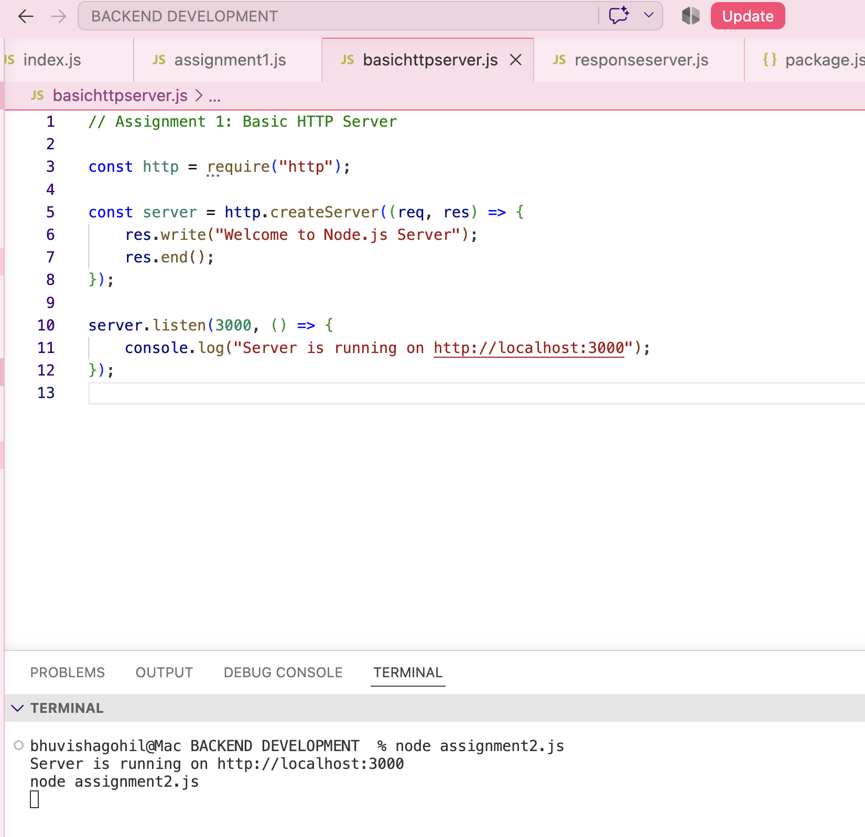

OUTPUT:
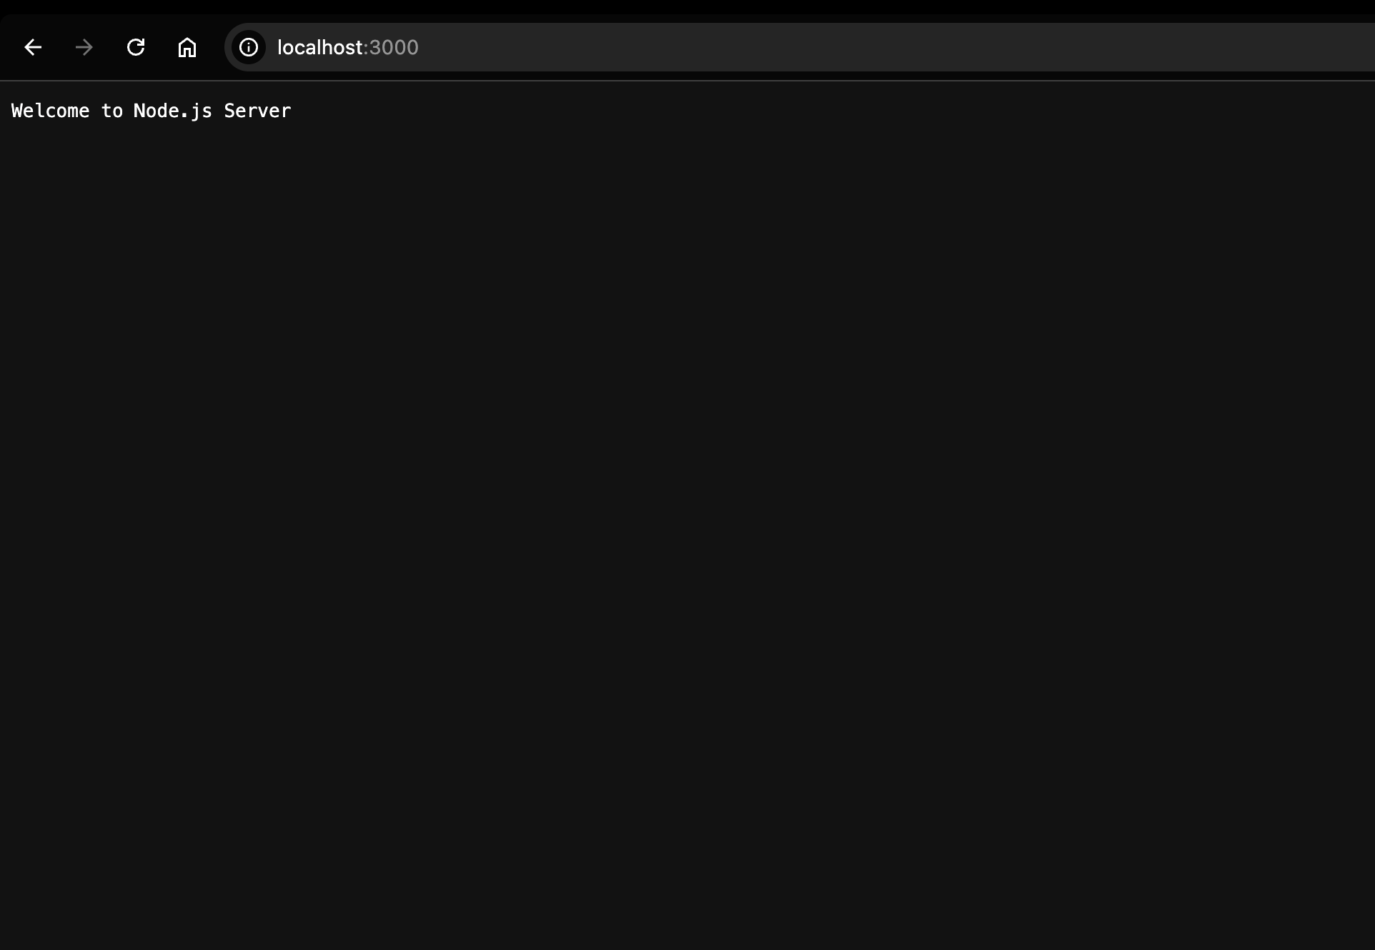

Assignment 2: HTML Response Server
Serve an HTML page using the Node.js HTTP module.
Create a Node.js server that returns an HTML page containing:
- A heading: Student Portal
- Student Name
- Course Name
- College Name
- A welcome paragraph
The page should display properly in the browser.
CODE:
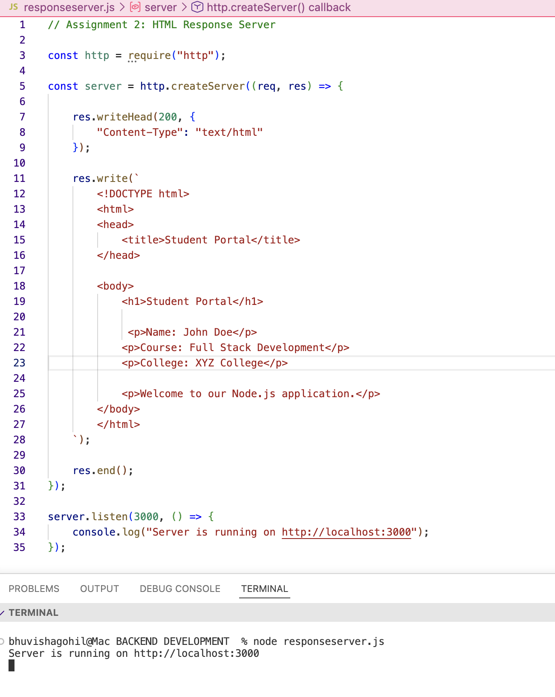
OUTPUT:
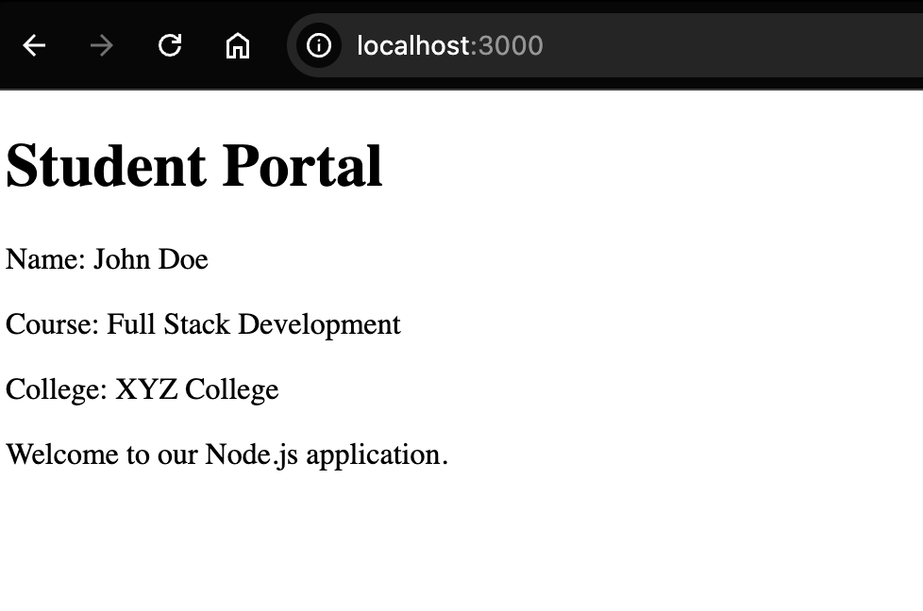

Assignment 3:Student JSON API

Create a simple REST-like endpoint that returns JSON data.
Create a Node.js server with the following behavior:
- When the user visits /student, return the following JSON object:
{
"id": 101,
"name": "John",
"course": "BCA",
"semester": 4,
"city": "Mumbai"
}
- If the user visits any other route, display:
404 - Page Not Found
CODE:
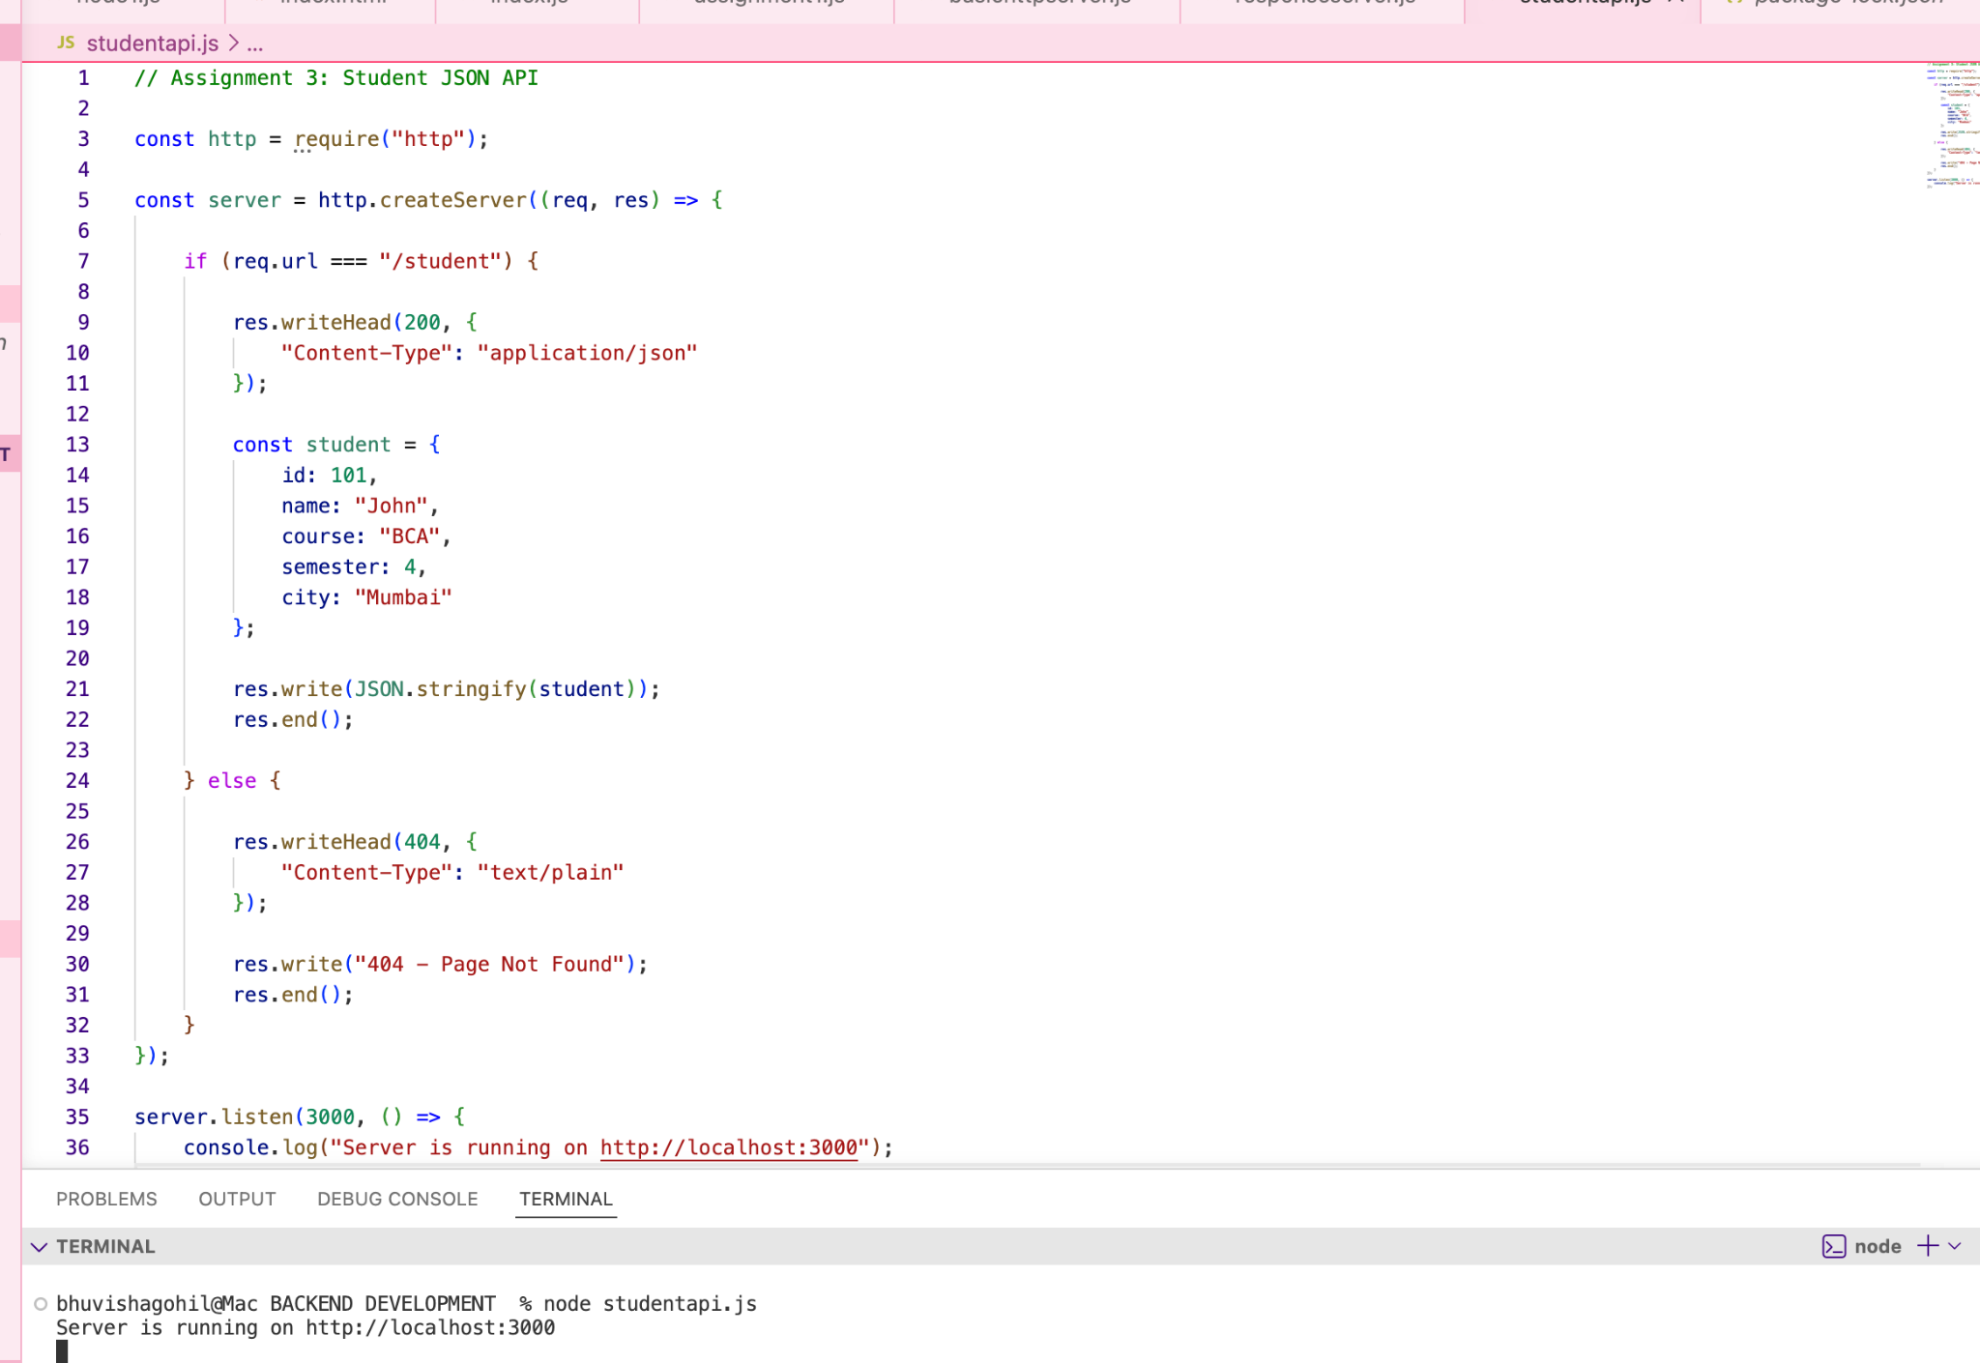
OUTPUT:
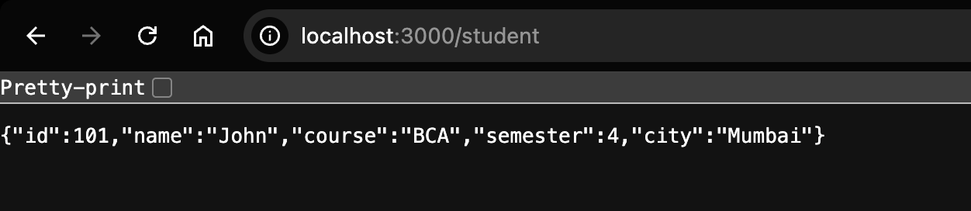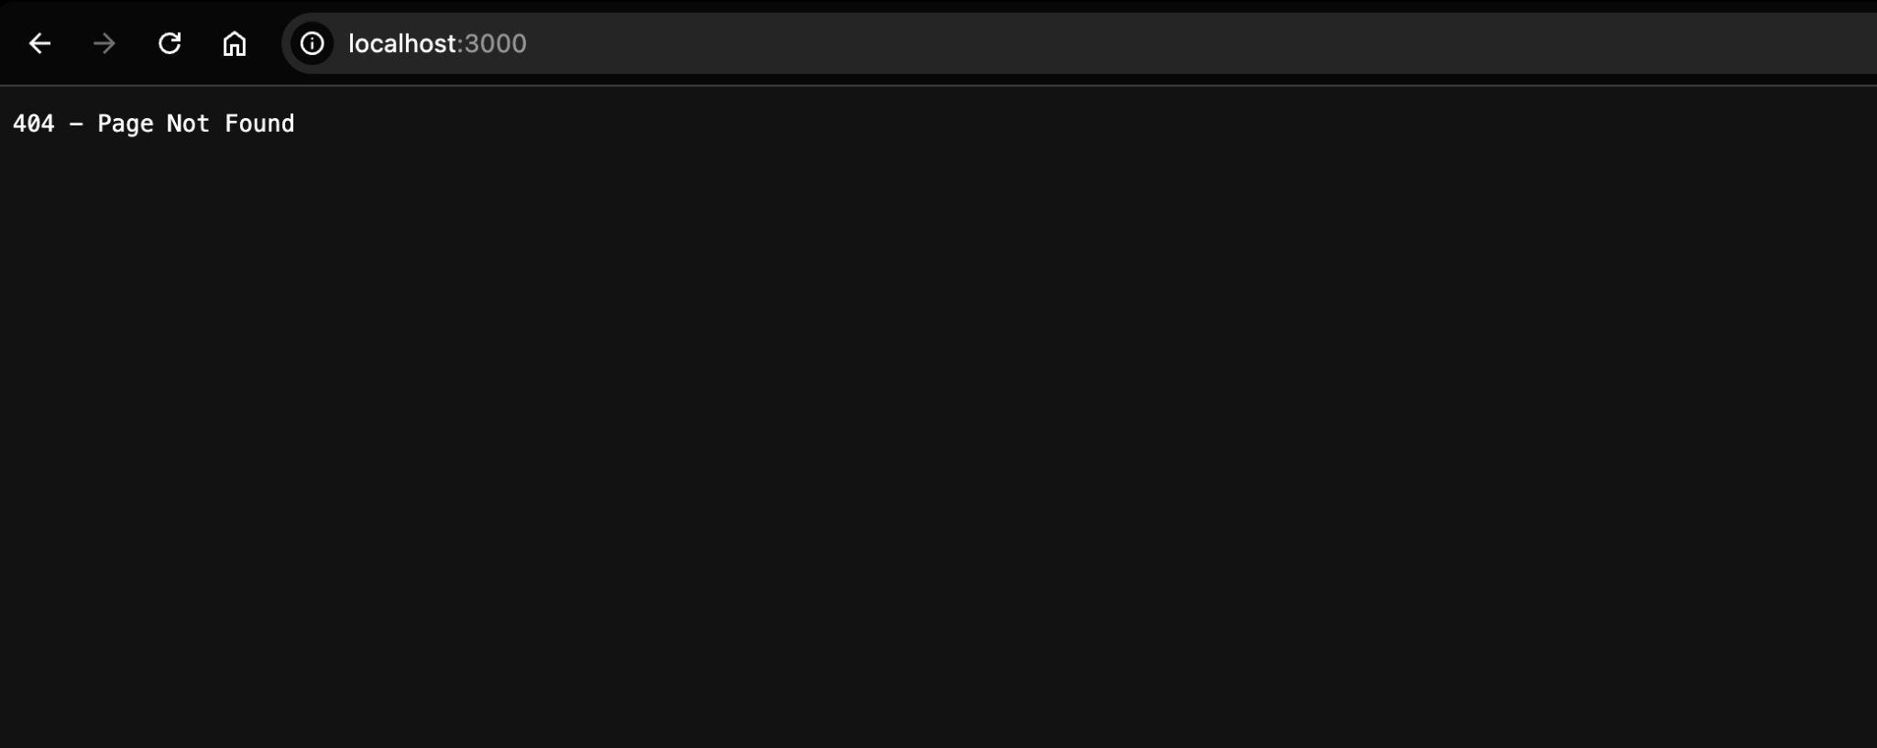


Assignment 4: Route Handling Server
Implement multiple routes using the Node.js HTTP module.
Create a server with the following routes:
- / → Welcome to Home Page
- /about → About Us
- /contact → Contact Information
- /services → Our Services
- Any other route → 404 - Page Not Found

CODE: o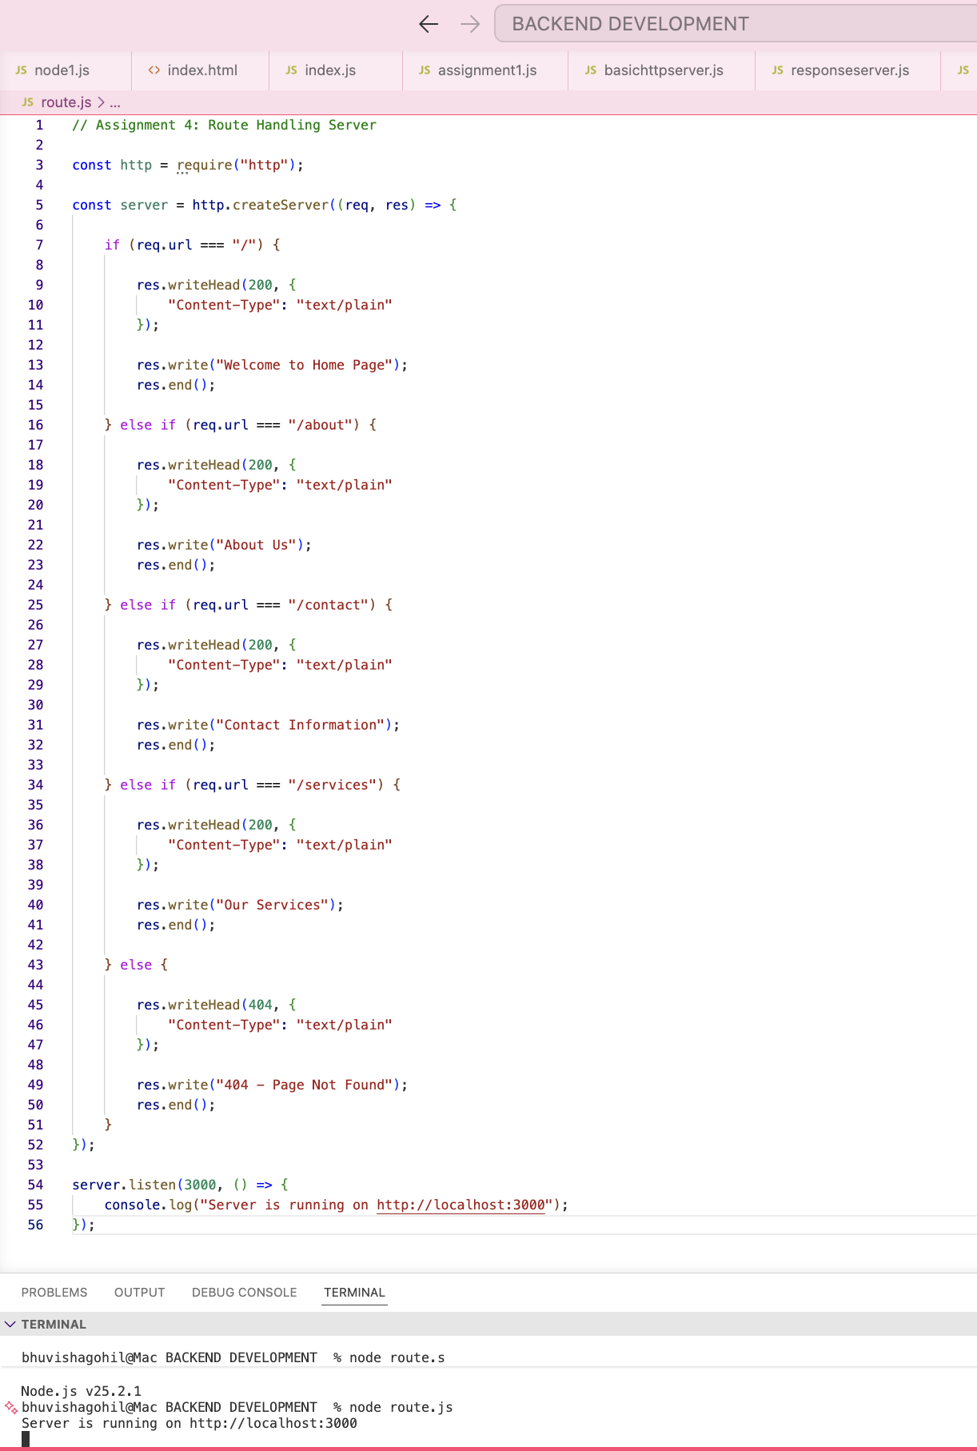
OUTPUT:
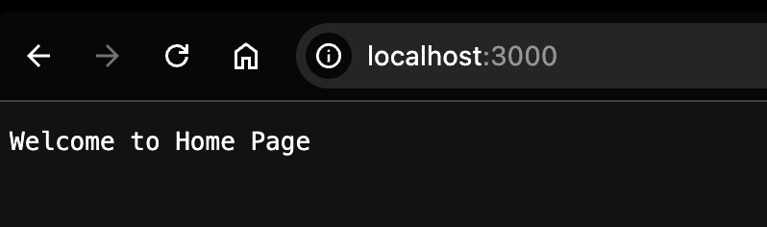
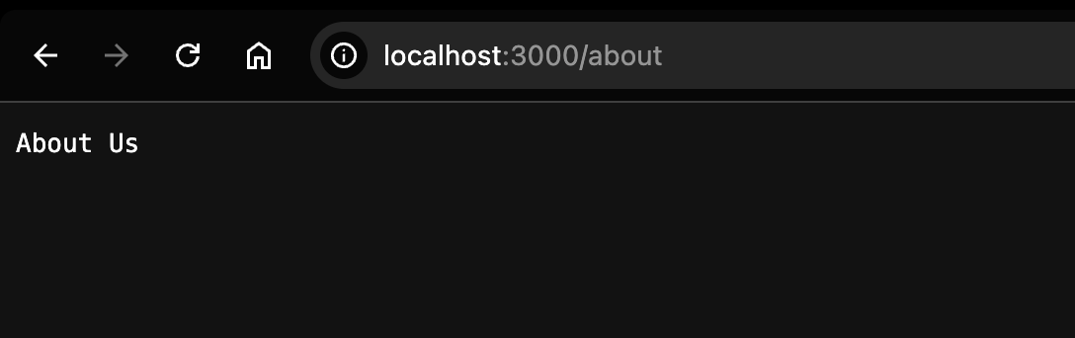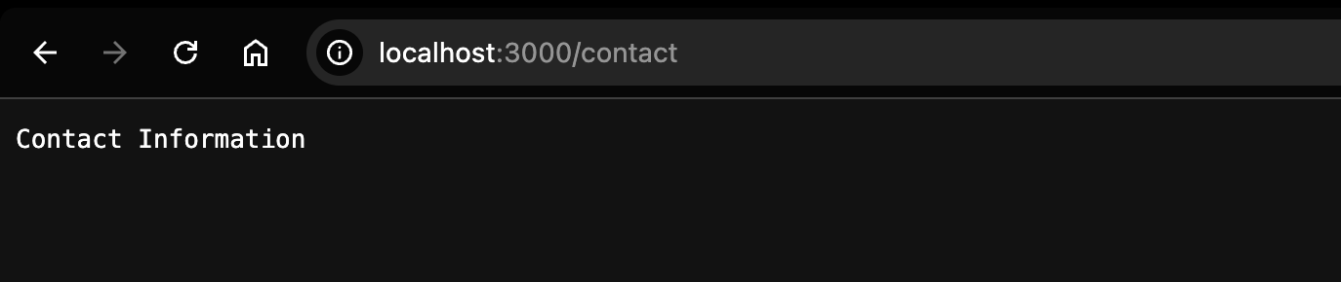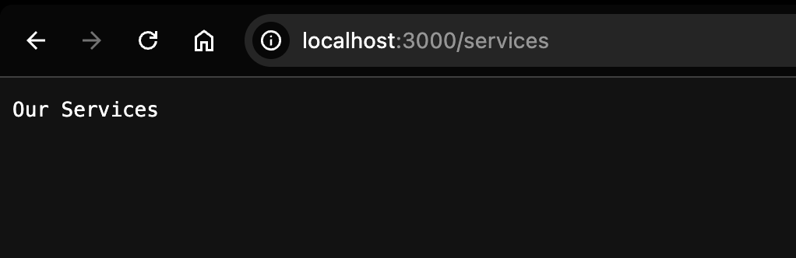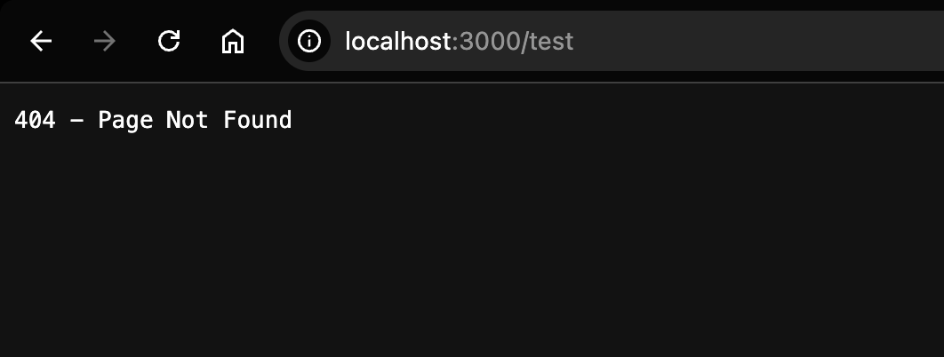

Assignment 5: Personal Portfolio Server

Create a simple portfolio website using only the Node.js HTTP module.
Develop a Node.js server with the following routes:
- / → Home
- /about → About Me
- /skills → Skills
- /projects → Projects
- /contact → Contact Details

Requirements:
- Each route should return an HTML page.
- Every page should have an appropriate heading and relevant content.
- Include navigation links to move between pages.
- Handle invalid routes by displaying 404 - Page Not Found.

CODE:
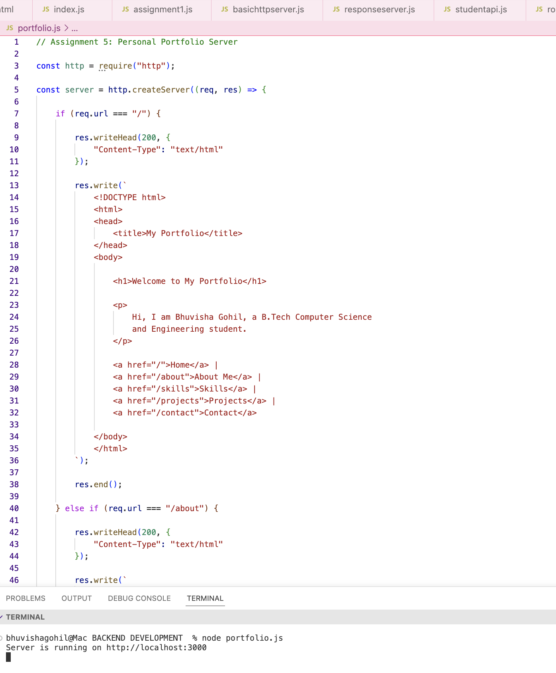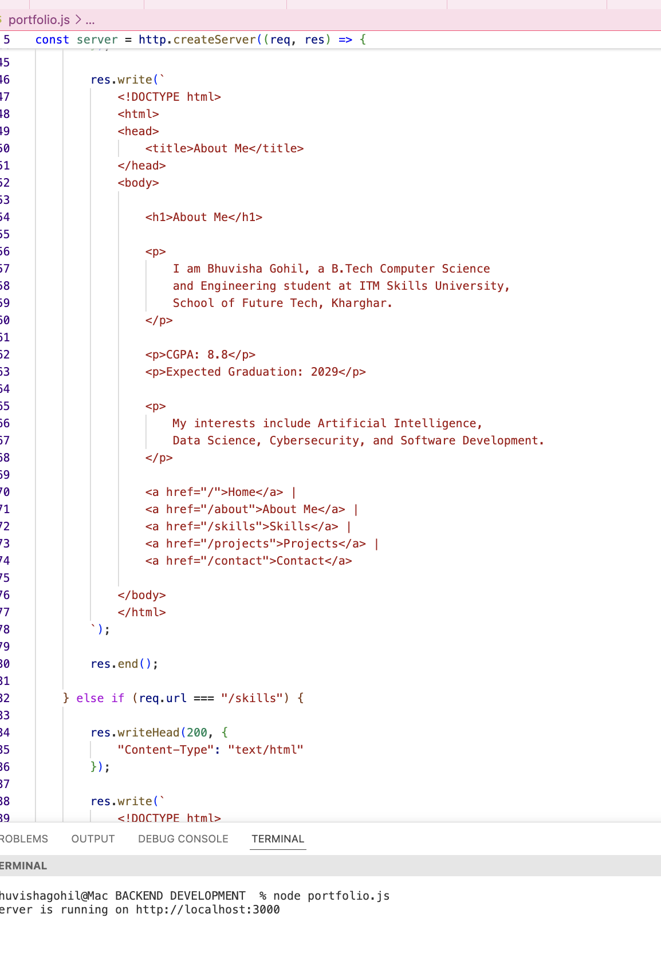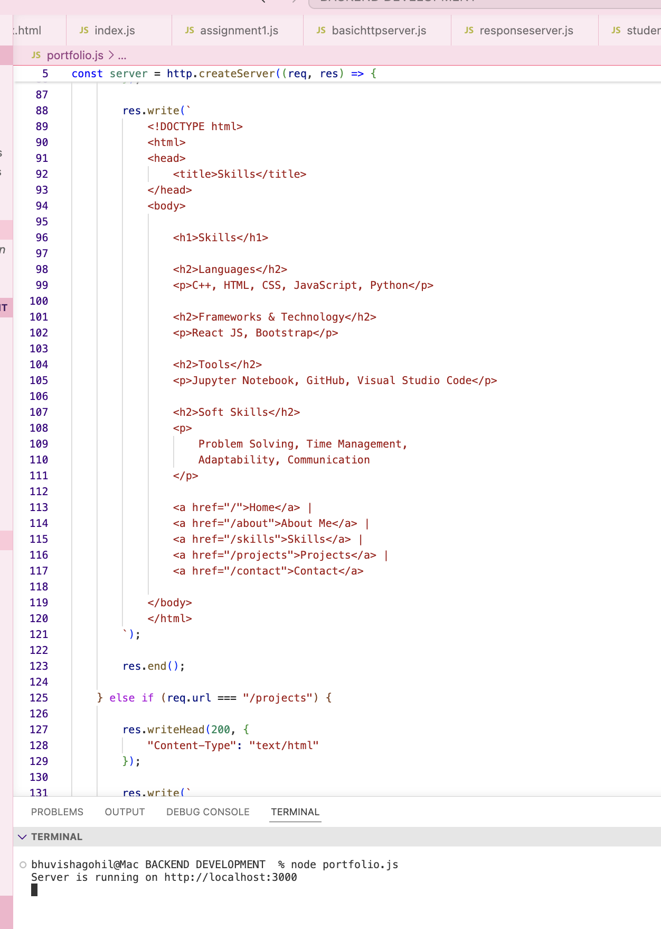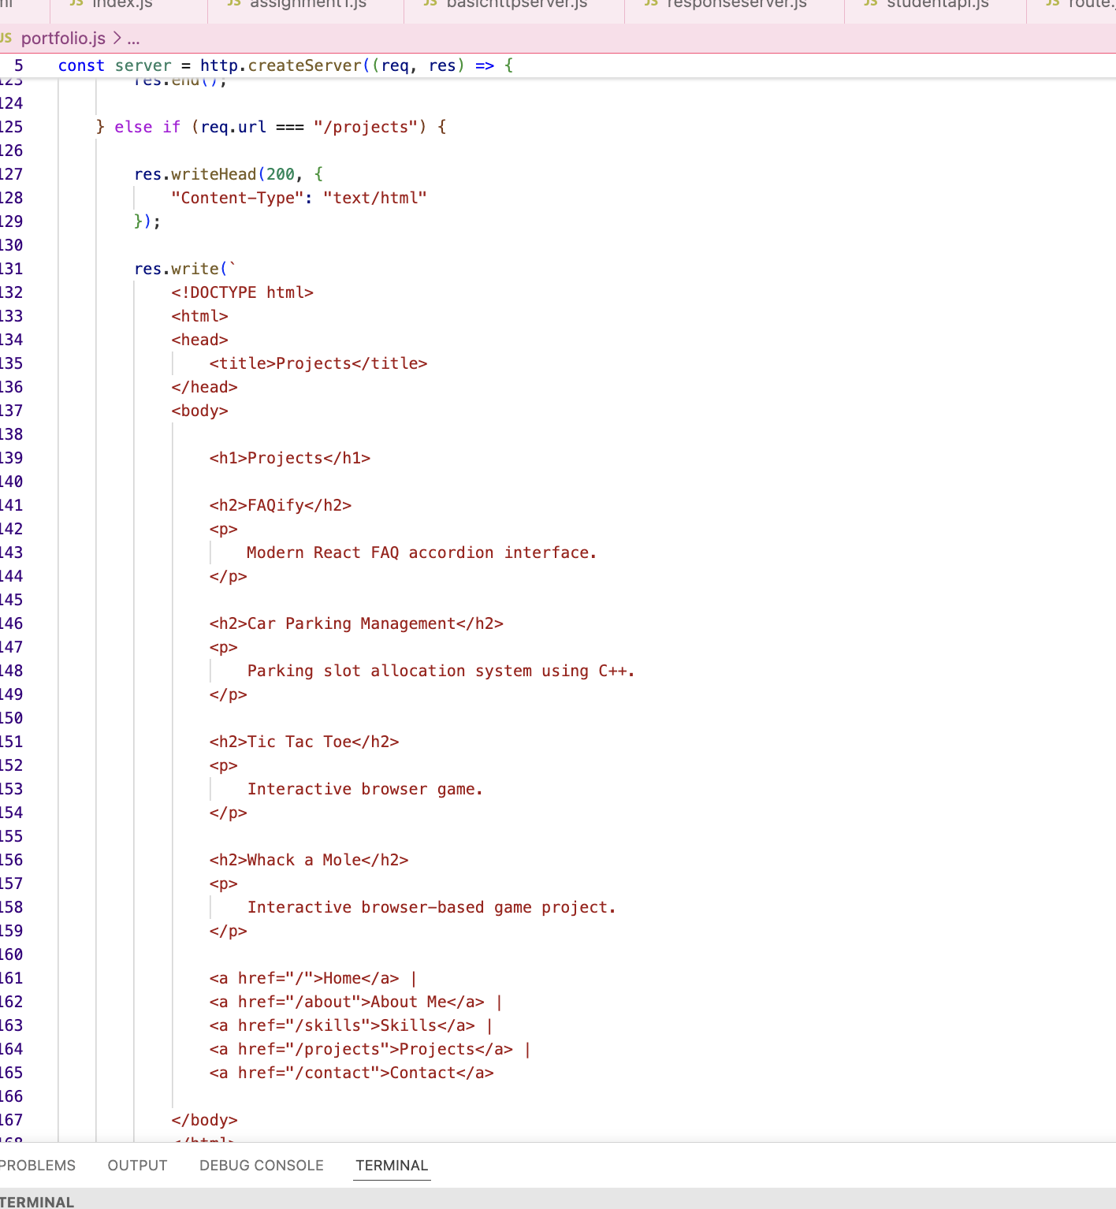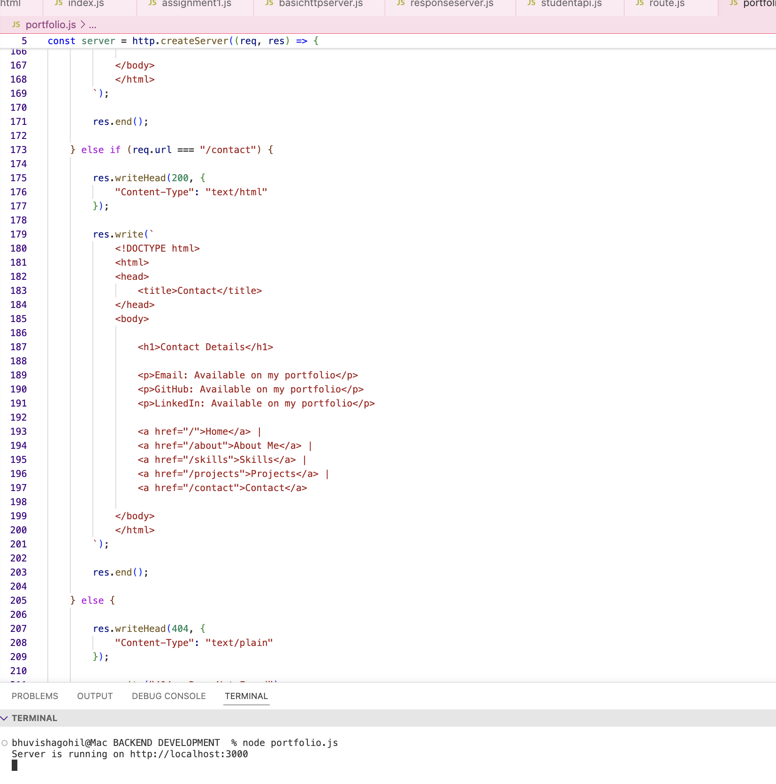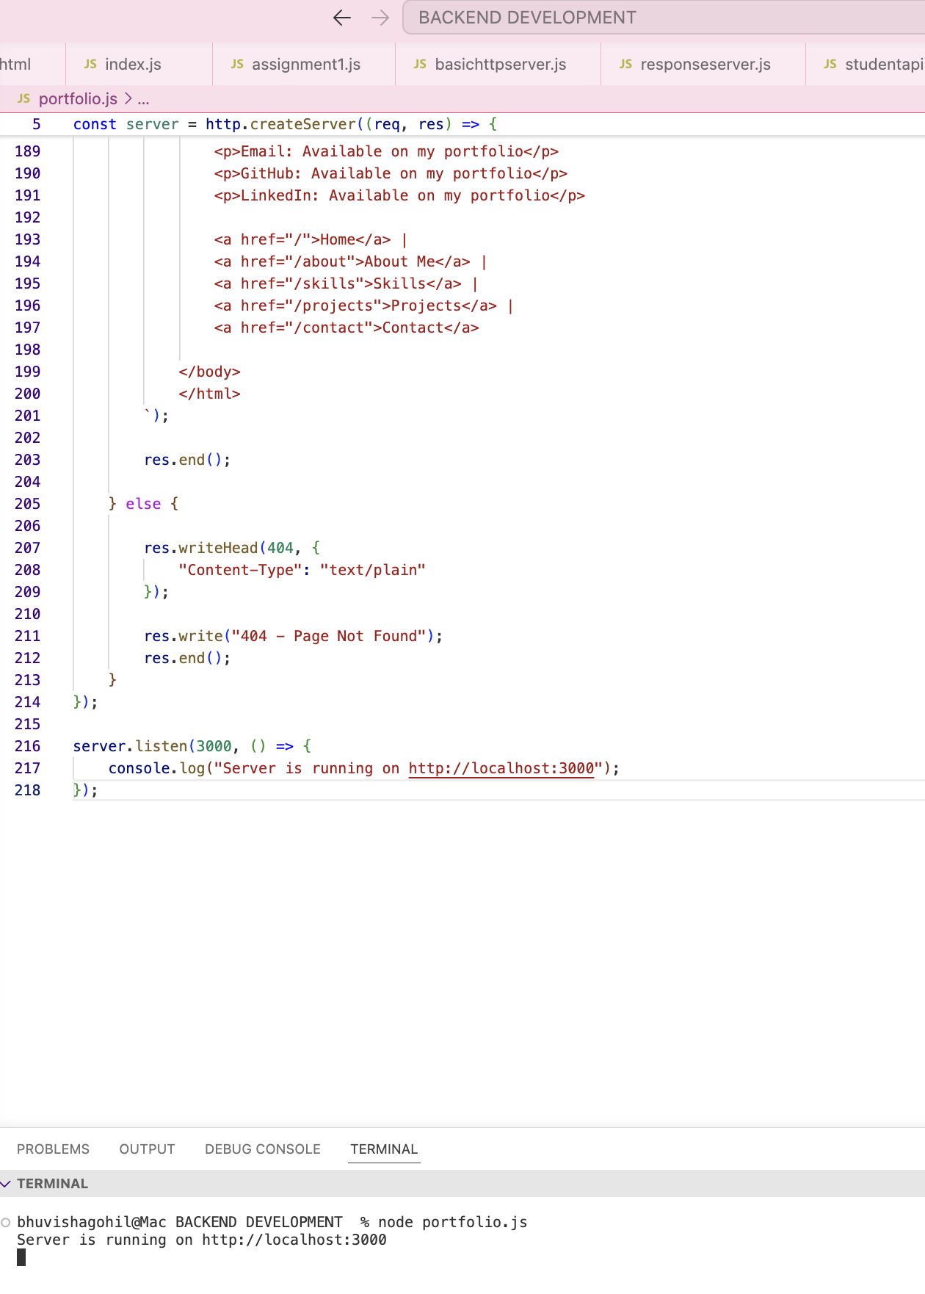

OUTPUT:
